ITCD 373
ETHICS AND CURRENT ISSUES:
In Communication Science and Technology
Spring 2013

Assignment 3: Team-led seminar and eDebate
Topic A: Newspapers/Websites Post List of Gun Owners

Gregory Andres, Gregory Greenleaf, Scott Greenwald, Michelle Meyer, William Nelson, Christian Nieto, Luke Pederson,
Vanessa Ramirez, Daysi Rivas

PROBLEM STATEMENT
Is it ethical to post a list of gun owners on the Internet without consent?
1) WHAT IS YOUR TEAM'S STRONGEST ARGUMENT?
- Knowledge itself isn’t the issue; it’s what people do with it. The pros outweigh the cons.
- The legal rights for public knowledge.
- Neighborhood safety and public safety.
- Accountability: (of people handing out permits) should we to be able to double-check them?

2) WHAT IS YOUR OPPONENT'S STRONGEST ARGUMENT?

- Criminals will have a “shopping list” of which houses are safe to rob.
- With your address made public, you could be the target of hate crimes.
- Publishing the list will punish those who are on it
- How it can be invading a person's privacy. No consent.
- The Internet is a huge audience
- Even if it's technically legal to release these public records, it's not ethical because it puts those who are on the list in danger
- The fact that a list like this is legal to publish is unethical
- Only 40% of guns out there are legally purchased

3) HOW WILL YOU COUNTER THEIR ARGUMENT?
- If hate crimes and being “an easy target” are real issues, then perhaps laws can be written to only post the gun owner’s name and city of residence.
- No consent public records
- Internet what will people outside the area do with the information anyway?
- The legal aspect of this issue tops the ethical aspect - Freedom of Information Law - It isn’t breaking any laws.
- Why would you go after anyone who you know owns a gun? There are worse consequences for being caught with a gun that is not registered.
- Regarding punishing for being on the list: One part of owning a gun is registering it. That is the consequence and responsibility of owning such a weapon. There are many illegal things someone can do to live more anonymously, but the punishment for being caught, in that case, would be much greater than the initial "punishment" of being on the list.

1. THE PROBLEM DEFINITION
The issue at hand is that a searchable list of gun owners was posted on a blog website for the public to see. The information had been legally obtained as the New York gun policy states that registered owners' address is to be accessible to the public. Posting a list of gun owners online is ethical because it allows the public the right of safety and reduction of future violence.
The list of gun owners is public information that can be obtained by anyone, so providing the list on the Internet -reword (made it easier for interested parties to find the information).
To consider:
- Permanent, global viewers
- Consider not defending the blog (Gawker), but instead defending the principle of this issue
- Information is public record
- As citizens, we have a right to know and have access to this information. If someone is not happy with that, they should work on changing the law.
- Similar to familiywatchdog.us, we as Americans deserve to know who is living around us and what could be endangering our families, important to include we don’t see gun owners as “criminals”.
2. HISTORICAL/LEGAL CONTEXT
With regards to the legality of the issue, it is clear that Gawker's release of the gun owner's list was well within the law. In fact, the official Handgun License Application for the City of New York clearly states:
"Pursuant to Penal Law Section 400.00(5), the
name and address of any person to whom an
application for any license has been granted,
shall be a public record."
In addition, Gawker obtained the information in 2010 via a Freedom of Information Law request, which allows members of the public to access records of governmental agencies. It provides a process for the requester to view and copy an agency's records. The agency in this case is the NYPD. The Freedom of Information Law is specific to the state of New York and is different from the federal Freedom of Information Act, which only deals with information at the federal level. (Freedom of Information Law, 2013)
Gawker was not the first online source to publish a list of gun owners on the Internet. In 2010, an anonymous source set up a website called Who's Packing NY. This list not only lists handgun owner's name, like the Gawker list, but also lists their full addresses. The list covers Rockland and Westchester counties. When this list was released on the Internet three years ago, it didn't cause such a stir. There also isn't information on any problems that have come up as a result of the public records being released.
The legislator from Connecticut Stephen Dargan wanted to also make these handgun owners list available under the Freedom of Information Act. The legislator came upon this proposal after the school shooting at Sandy Hook Elementary in Connecticut. Dargan told Fox News “Obviously, something needs to be done,” he said. “I want to make sure we look at all the ways we can prevent another horrific shooting from happening.” (Chakraborty, 2013)
To consider:
- Freedom of Information Act
Sources:
Committee on open government, freedom of information law. (n.d.). Retrieved from
http://www.dos.ny.gov/coog/foil2.html
Cook, J. (2013, January 8). Retrieved from http://gawker.com/5974190/here-is-a-list-of-
all-the-assholes-who-own-guns-in-new-york-city
Chakraborty, B. (2013, January 6). Connecticut lawmaker wants names of gun owners to
be made public. Retrieved from
http://www.foxnews.com/politics/2013/01/04/connecticut-lawmaker-wants-names-gun-owners-to-be-made-public/

3. STAKEHOLDERS
These days, moving into a new neighborhood is a roll of the dice. You never know who you’re going to have living on your block. Being a stakeholder means that you have some part to play in the big picture, and when it comes to guns, you just happen to be a stakeholder if the gun owner lives within a 5-mile radius of your home. According to the Texas Parks & Wildlife Department, a .45 caliber bullet can fly from 1.5 to 2.5 miles and a 7 mm can go up to 5 miles (TPWD, n.d.). This was known all too well by the parents of Stephanie Nicole Ella, whose daughter was the victim of a stray bullet shot at the New Year revelry; she was seven years old when she hit the ground (GMA, 2013).
As someone living in the same neighborhood of a gun owner, the threat should be made known. Parents can make informed decisions and weigh the pros and cons. Some neighbors might feel safer knowing that someone living next to them can drive away hostile people or wild animals. Gun owners can feel confident that their weapons are registered and with a public notice, those people can have greater accountability. Giving this notice door-to-door would be a bit extreme, but having an online and print record available and open to the public upon request might make that new move less dicey.
Concerned citizens who don’t own guns claim that a public list would give criminals the comfort of knowing they wouldn’t get shot during a robbery. However, common sense would dictate that only a fraction of the gun owners in the country would even be on the list, so that criminal would be taking a chance either way. An article posted by CBS states,
Those who want gun owner’s’ names disclosed say it would keep the government accountable for its decisions about whom it grants permits to, allow people to know who among their neighbors are armed, and help firefighters know whether they are entering a burning building where there may be weapons. (CBS, 2011)
Even with all the good that such lists can do, there are still going to be those that will use the information for nefarious purposes. Although, isn’t that true for about everything? That’s where law enforcement comes into play, making them another stakeholder. With the few “nutjobs” out there, police will have to take care of them. You’ll find stakeholders in the most unlikely places. A Rockland County prison is such a place. Inmates saw a list of registered gun owners in a New York newspaper and began threatening the prison guards with the information they obtained (Fox, 2013). However, this information wasn’t obtained online, but in print. The original issue was the online access, which was printed without the addresses, only the names of the gun owners.
To consider:
- Citizen gun owners and their families
- Gun shops/salesmen
- Government regulators
- Concerned citizens/neighbors
- Public media
- Law enforcement
Sources:
CBS. (2011, March 11). Illinois Gun Owners Rally. Retrieved from http://stlouis.cbslocal.com/2011/03/11/illinois-gun-owners-rally/
Fox News. (2013, January 4). Inmates using newspaper's gun owner map to threaten guards, sheriff says. Retrieved from http://www.foxnews.com/us/2013/01/04/law-enforcement-latest-critics-on- public-display-gun-owner-data-officers/
GMA News Online. (2013, January 6). Gun owners in Nicole's neighborhood told to present their guns for inspection. Retrieved from http://www.gmanetwork.com/news/story/288998/news/nation/gun-owners- in-nicole-s-neighborhood-told-to-present-their-guns-for-inspection
TPWD. (n.d.). Distances Bullets Travel. Retrieved from http://www.tpwd.state.tx.us /learning/hunter_education/homestudy/firearms/ bullets.phtml

4. COMPETITIVE ANALYSIS
The issue here can go beyond just the gun list of owners that were posted. Given the fact that there are two sides to every topic we’ll take a look at what good comes from our side. As a law-abiding citizen, through the constitution I have the right to freedom of speech, which is not denied so long as I am not breaking any laws. This is a free country, and what Gawkers did by posting this list, which is public record, was perfectly within their rights through freedom of the press. All they are guilty of is committing a good service to a community who may or may not give a damn. Making it completely convenient for folks, who care, to look at. Nothing was wrong in doing what was done.
In retrospect our opponent can say otherwise and believe that such a list will cause unnecessary retaliation and violence towards all gun owners. They may also believe that this is a case of infringed privacy. Nothing is private anymore, with the Internet and social media; this is the “era of openness”. Unless there are an entirely new set of constitutional laws written specifically for the use of internet and media it’ll have to remain to be agreed that so long as public record is public record than it’s free game and our core privacy values are completely changed since 1890 when Samuel Warren & Louis Brandeis first came up with the “Right to be Alone” act.
Sources:
"Is Anything Private Anymore?" Simply Zesty Is Anything Private Anymore Comments. SimplyZesty, 1 Nov. 2009. Retrieved from http://www.simplyzesty.com/social- media/private-anymore/#
Laniel, Stephen R., Samuel D. Warren, and Louise D. Brandeis. "The Right to Privacy." Warren and Brandeis, "The Right to Privacy" Harvard Law Review, 15 Dec. 1890. Retrieved from http://www.washingtonpost.com/wp- dyn/content/article/2006/07/28/AR2006072801483.html
Lithwick, Dahlia. "Is Anything Private Anymore?" Washington Post. The Washington Post, 30 July 2006. Retrieved from
http://groups.csail.mit.edu/mac/classes/6.805/articles/privacy/Privacy_brand_ warr2.html
5. ECONOMIC ISSUES
For Gawker, it's easy to see why they would benefit economically from releasing an attention-getting, controversial list. Gawker, like many websites, is advertising-based. The more page views their website receives, the more impressions and clicks their advertisements will get. In turn, Gawker will make more money. Since Gawker's viewing statistics are public, anyone can see their daily page view reports. Not surprisingly, on the day Gawker released the gun owner's list, January 8, the website had 4.5 million page views ("Gawker.com traffic and," 2013). Although their page views were not nearly as high as the days surrounding the Sandy Hook Elementary School shooting, they were the highest since that time. Gawker may have been trying to release a similarly newsworthy and controversial story to drum up their ratings.
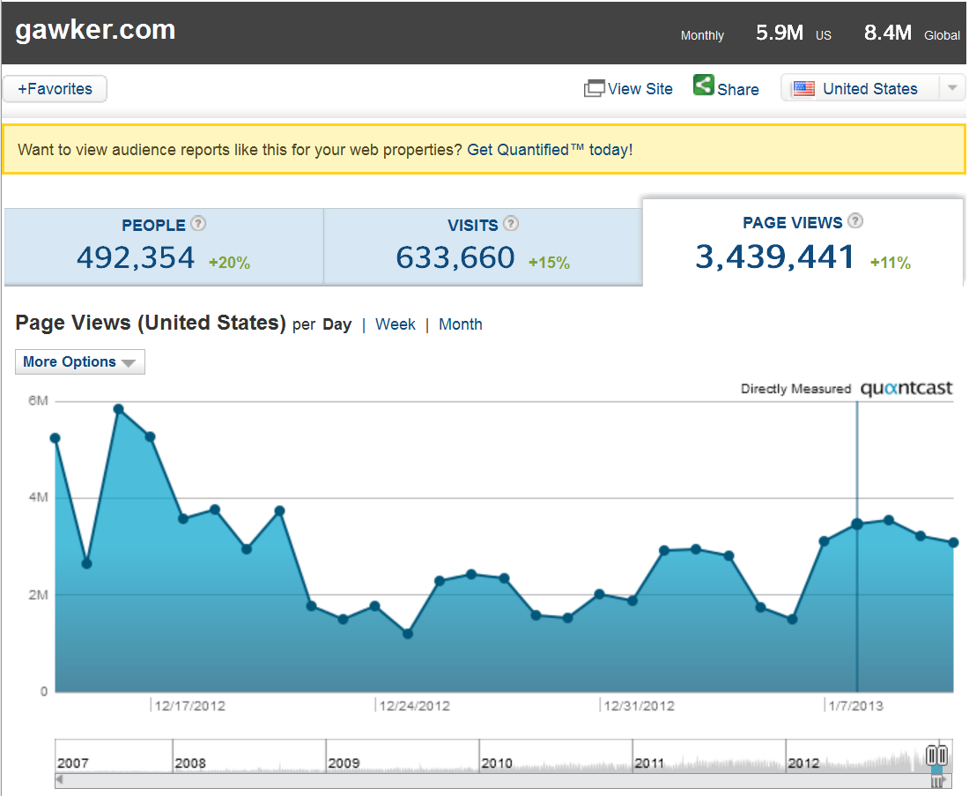

The figure above shows how Internet traffic to gawker.com rose higher than it had been since 18 days ago.
Another economic factor worth considering has to do with gun shops. Considering that many gun owners most likely aren't happy being on the list, it worth wondering if gun shops are seeing less business. If gun owners wish to keep their gun ownership anonymous, they may buy guns illegally on the black market in the future. The gun industry and ammunition industry is affected economically. This issue creates a significant presence in their minds to protect their rights to own these firearms and ammunition such as high caliber, assault rifle ammunition, tactical assault rifles.
To consider:
- Gawker ad money, more website hits after posting this story
- Gun shops, possible loss of business due to list being posted. If someone doesn't want to be on the list, they may prefer to buy a gun on the black market in the future, instead of buying legally, filling out form, etc.
-4.5 million on January 8th (page views on the day the list was released)
Sources:
Gawker.com traffic and demographic statistics by quantcast. (2013, February 12). Retrieved from http://www.quantcast.com/gawker.com
6. TECHNOLOGICAL FACTORS
We all know that technology is always evolving and over time everything will become digitized, and at the same time more and more things are becoming public record and not staying private. We can relate this to something like a terrorist attack where we had something tragic happen and to help try and prevent that and prepare everyone some things become less private. We had the tragic event of school shootings and because of that we have given up things in order to make people feel safer and more at ease. The record of gun owners were already public and anyone was capable of accessing them if they wanted to, the same thing will happen here, if you want to know who owns a gun instead of going down and asking for the information it is readily available via your computer or device that can access the internet.
NY already has a policy that puts the name of and address or registered pistol owners on public record. While many people have Internet access, not many can easily find and access they public records. By republishing these names on the Internet, all the bloggers did was make public relevant public information more accessible to the Internet.
To consider:
- Internet access is common
- almost anyone can access
- public knowledge is something to be aware of
- “terms and conditions agreement” of owning a gun
- What is considered “public access” today?

7. RECOMMENDATIONS
A recommendation that can taken for this case would be still keeping this list online, but have restricted access. This could be only allowing residents that live in that area to view whom owns a gun. The information could be provided with time restrictions after a background check to verify whether or not the requester needs the access. This could also be done by allowing some kind of logon that verifies the information of the resident to make sure that person resides in the area of the city. Having the websites that are listing the names be more private will help for the information not to be public to everybody. Basically if someone is extremely interested in knowing in which kind of neighborhood they will be either, buying, renting, or residing they can access it.
The actual bill that was put into action in January 2013 by Governor Andrew Cuomo, which gave the option of gun owners to keep their registration information private. The bill also gives the option to already registered gun owners to go to county clerks and make their information private. The government will still keep records of registered gun owners and ammunition sales for the use of law enforcement, but it will now be private information. There are other stipulations regarding the bill, but essentially the bill promotes privacy of the information.
Nothing has changed regarding the ability of Journalists to mention potentially private personal information. The governor stated that the bill came into effect because, “And to say to the newspapers that they can't publish information that the public wants to know, I think is the true violation of our Constitution.”
To consider:
- Verdict, allow gun owners to choose whether their info is private or not.
Sources:
http://www.usatoday.com/story/news/nation/2013/01/15/ny-law-allows-gun-data-to- stay-private/1837563/
8. PROS AND CONS
The Advantages:
The bill will allow gun licensees to opt-out of having their personal information from being released to the public under the Freedom of Information Law (FOIL). This bill allows a provision that will permit for a private statewide database of all gun owners and ammunition sales that would only be accessible by law enforcement and mental health professional in order to enforce the state’s laws. All gun licenses would need to re-certify every 5 years and would be up to the local officials to grant the privacy opt-out only if there is no inaccurate information when applying for the request.
Pro: Openness and not secrecy keeps government accountable to citizens and protects the public's interests. Access is the only way for citizens to know that permits are being issued properly and correctly. It’s the public’s business to know who has been given the legal authority to carry a gun in the case there us a dispute or disagreement with peers at work or school or neighbors to know the situation they might be dealing with. (Stanley 2013)
The Disadvantages:
The bill infringes the First Amendment, which guarantees free speech. This would violate the constitution by not allowing news agencies from publishing private information to the public.
The opt-out option does have some restrictions. Gun licensees will have to meet the following criteria in order to opt-out of the disclosure. The criteria include only to law enforcement officials, victims of domestic violence, people that served on a grand jury and those who fear for their safety or unwarranted harassed, which can be claimed by anyone.
Con: Allowing anyone—neighbors, co-workers, thieves—to take a virtual tour of any community, conveniently sharing whether or not the homeowner had a concealed carry permit – along with the permit holder's full name and address isn’t cool. In short, these people were treated like criminals. (Obeshian, 2013)
Sources:
Chapa, L. (2013, January 16). Ny gun law restricts public access to gun owner data. Retrieved from http://www.rcfp.org/browse-media-law-resources/news/ny- gun-law-restricts-public-access-gun-owner-data
Obeshain, Mark. "Let's Stop 'outing' Concealed Carry Permit Holders." Dailypress.com. Daily Press, 12 Feb. 2013. Retrieved from http://www.dailypress.com/news/opinion/dp-nws-oped-obenshain-0213- 20130212,0,6129236.story
Stanley, Ginger. "Gun Permits Are the Public's Business." Dailypress.com. Daily Press, 12 Feb. 2013. Retrieved from http://www.dailypress.com/news/opinion/dp-nws- oped-stanley-0213-20130212,0,5934915.story

